[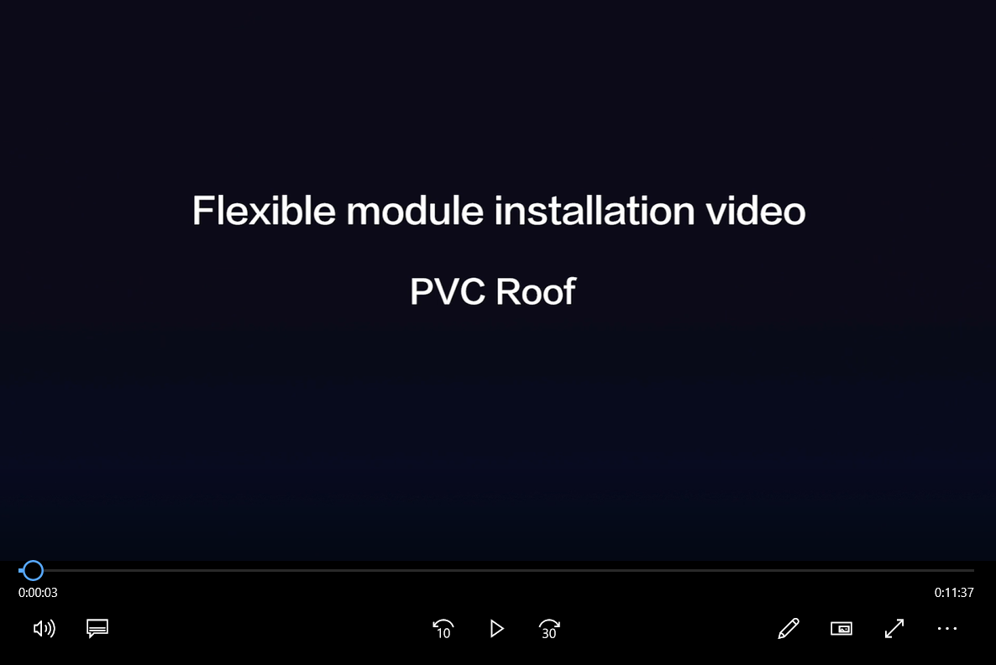](file:///C:/Users/janci/Project%20Zero%20Dropbox/Techniek/Panelen/Sunport/handleiding%20installatie%20Sunport%20flex%20panel/Installation%20video%20for%20MWT%20flexible%20panel-EN.mp4)